# Requirement document for Change in PMS and calculus

## Introduction/Purpose:

We have an in-house developed PMS and calculus application used by all the verticals for various purpose.

The Application is used for multiple operations in following ways

* Query Builder
* Employee Feedback
* Knowledge portal
* Asset inventory
* Software Ticketing
* Training evaluation
* Petty cash
* Vendor payout Etc…

The requirement is that we need to do certain changes to optimize the application

Following are the changes required :

**PMS**

1. Presently PMS home page is displaying multiple shortcut menus, we need to remove the same as they are either no longer used or used as per user requirement, we need to remove Query Builder,Negative Dedup,Salary View,Employee Feedback From with reference to SCR1

SCR1



1. Asset inventory module : there are multiple changes required in asset inventory module
2. need to add download option for downloading upload file format, reference SCR2

SCR2

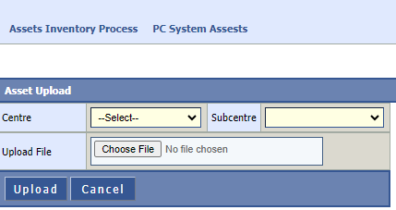

1. Asset assignment to client e.g. employee : the requirement here is , we are also assigning assets to client side.

Here while assigning asset we will have to provide the dropdown above the “enter emp code to search user “ field, where user will select PAMAC/CLIENT

When the client option is selected , the system will allow to enter client id for search (client master to be created ) like it is allowing for employee in current version.

Label “enter emp code to search user “ to be changed as “enter emp / client code to search user “

Reference screen below

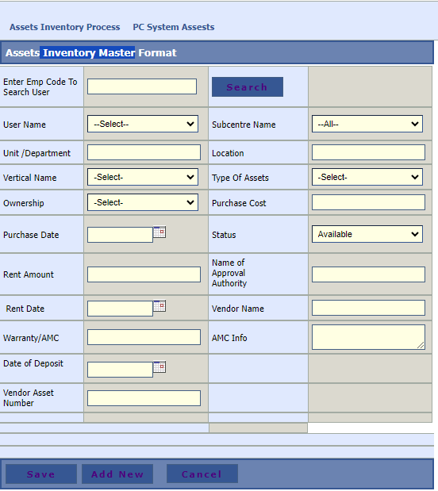

1. Right to assignee multiple assets should be restricted to IT ADMIN and Client only
2. Master table for type of asset to be created
3. Need to add value Declare Scrap in inventory master detail page, as a process user will first change the status from available to declare scrap, then user should be able to scrap the particular asset reference SCR3

SCR3



1. Cosmetic changes to be done like label spelling correction etc. reference SCR4

SCR4

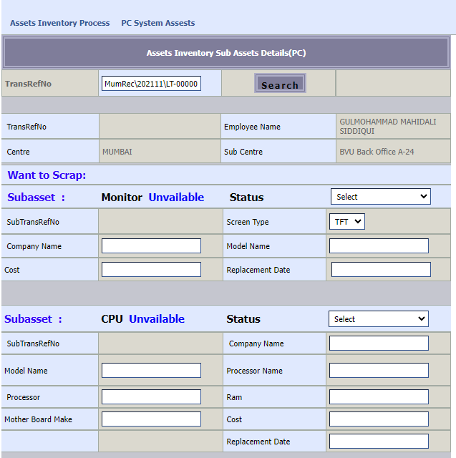

1. When Assets description updated then update tblSystemDetailsInfos this table also (check same column in both table)

**Calculus**

1. If User Select (repairs and maintenance) status from dropdown Account Head then display transrefno in vendor payment request page from PMS to know cost for repairs and maintenance Reference SCR5

SCR5

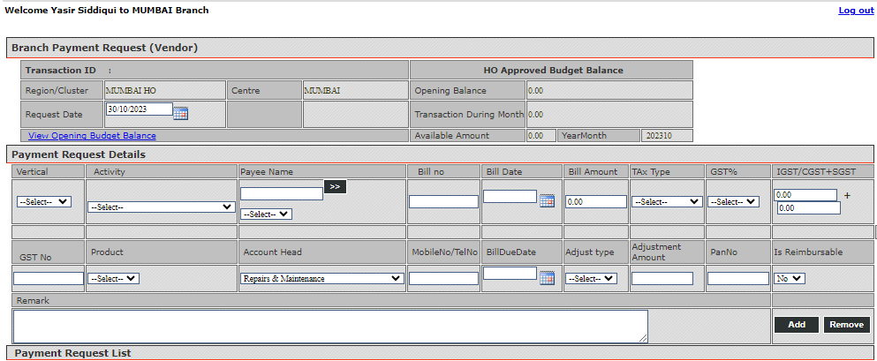

1. Display Problem Type and Problem Details on Ticket Status page also give it to change by IT team. Reference SCR6

SCR6

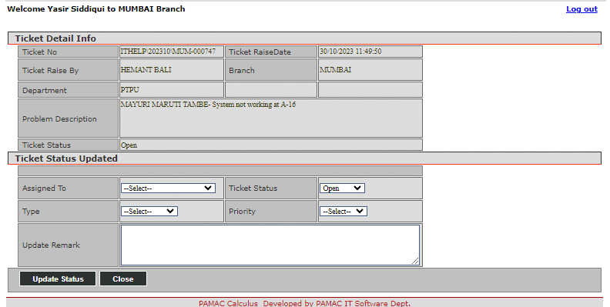

1. Make Status as optional if user not select only status then show all Reference SCR7

SCR7

